Advanced Training with Power
What is training with Power and data?
Overview
The singular goal of an athlete’s training program is to induce the physiological (and psychological) adaptations that contribute to performance improvements in target event(s).

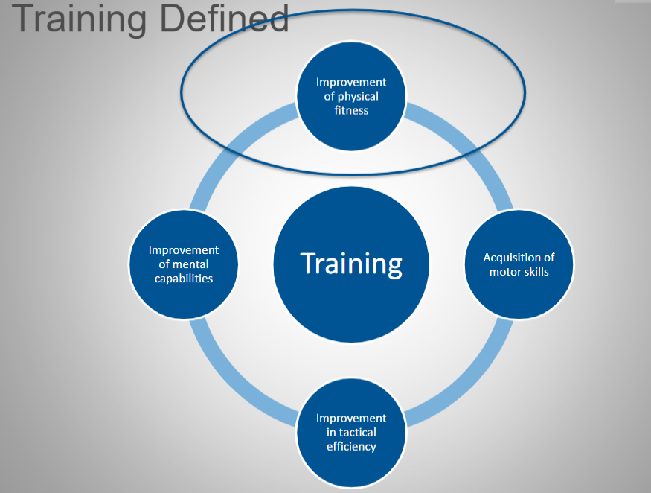

Elite athletic performance involves the integration of muscular, cardiovascular, and neurological factors that function co-operatively to efficiently transfer the energy from aerobic and anaerobic ATP turnover into velocity and power. (Endurance exercise performance: the physiology of champions ‘Michael J Joyner and Edward F Coyle’).
ATP Generation Systems
Adenosine Triphosphate (ATP)
A compound consisting of an adenosine molecule bonded to three phosphate groups, present in all living tissue. The breakage of one phosphate linkage (to form adenosine diphosphate, or ADP) provides energy for physiological processes such as muscular contraction.
ATP is generated through three different energy systems. The energy system through which the body generates it depends on the Intensity and the Duration of the exercise being performed.
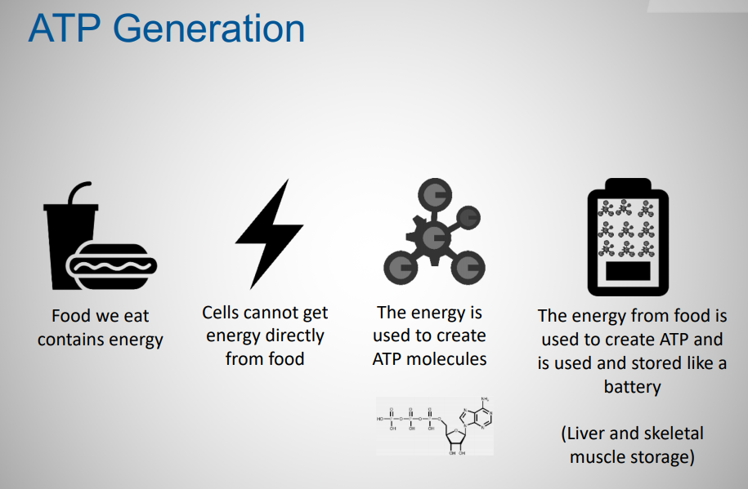
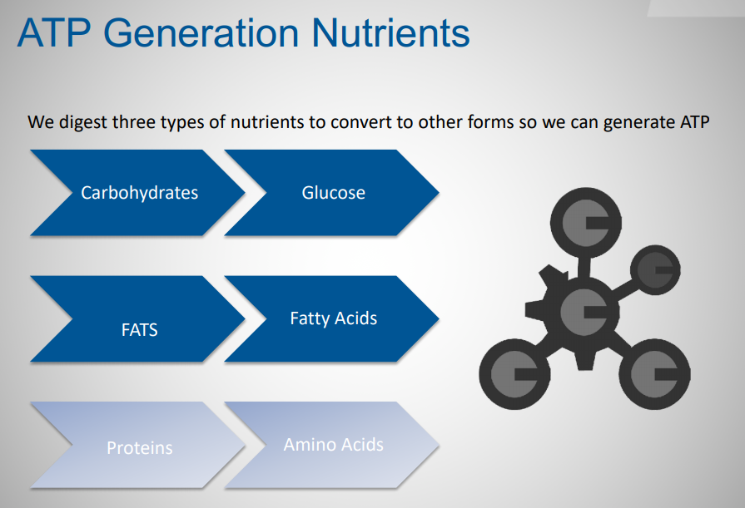

- ATP – PC system = very quick, explosive exercise
- Anaerobic lactic system = moderately - intense exercise lasting several minutes
- Aerobic system = long - duration exercise

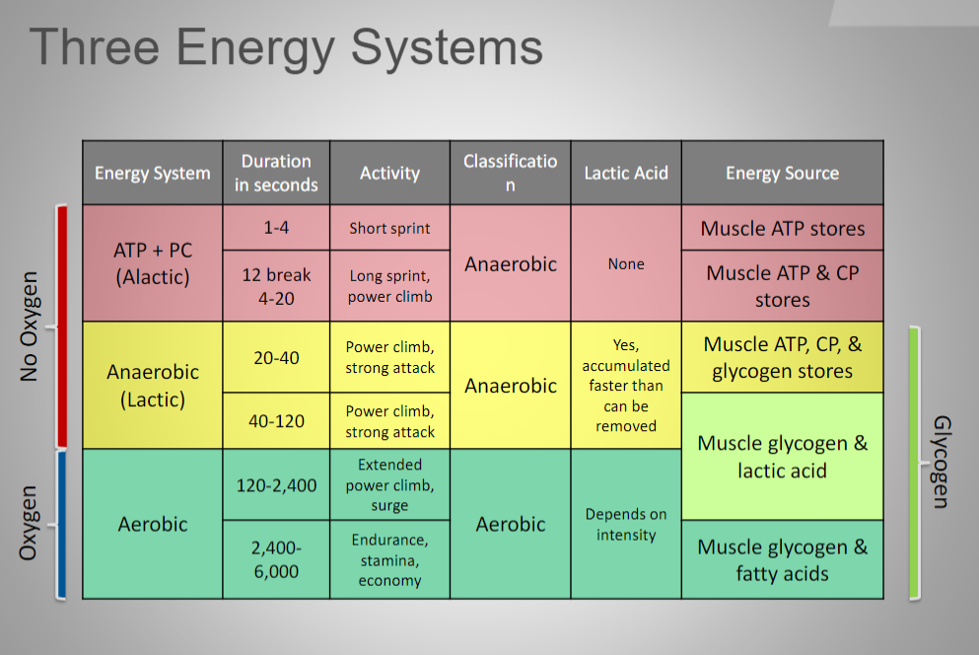
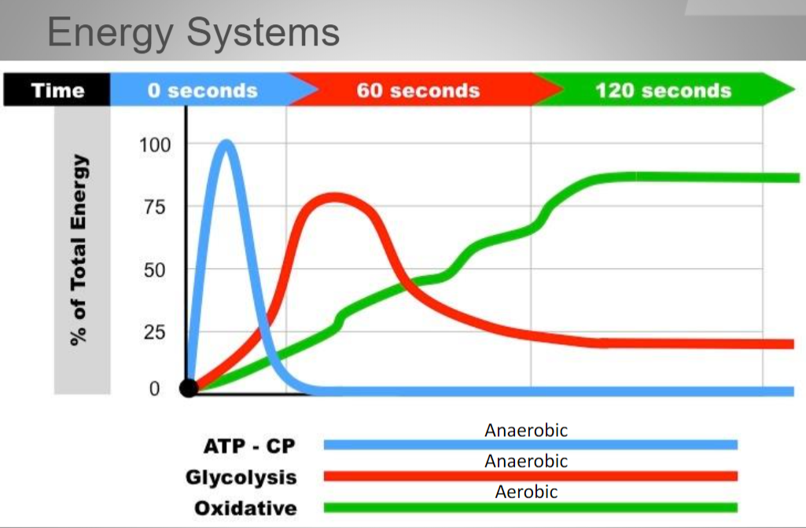
Training Elements
- INTENSITY (How Hard)
- VOLUME (How Much and How often)
- REST (How Much)
The Role of Data
- Quantify the elements
- Quantify the dose
- Quantify the response
- Quantify the problem
The answer lies in understanding what the process of training is: The stress, Strain, Adaptation Technique System of Monitoring.
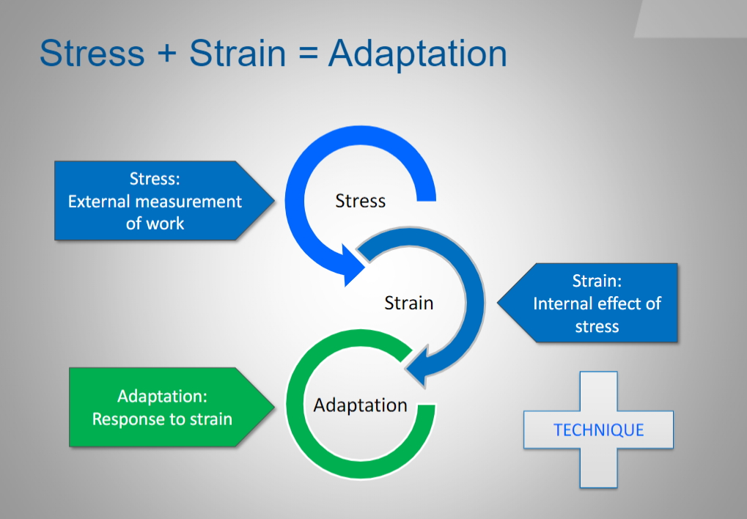

Quantifying the Process
- A single session of training generally has a positive adaptive signal
- Training over time (load) introduces the need to balance the positive and negative adaptive signals
- Training loads are complex and multifaceted
- Quantifying the process gives insight and control
Quantifying the Training
Monitoring the Systems Health - Subjective Insights:
- Making the Diagnosis (Needs)
- Dose – Load – Adaptation
- Dose – Load – Adaptation – Performance
- Dose – Load – Adaptation – Performance – Improvement
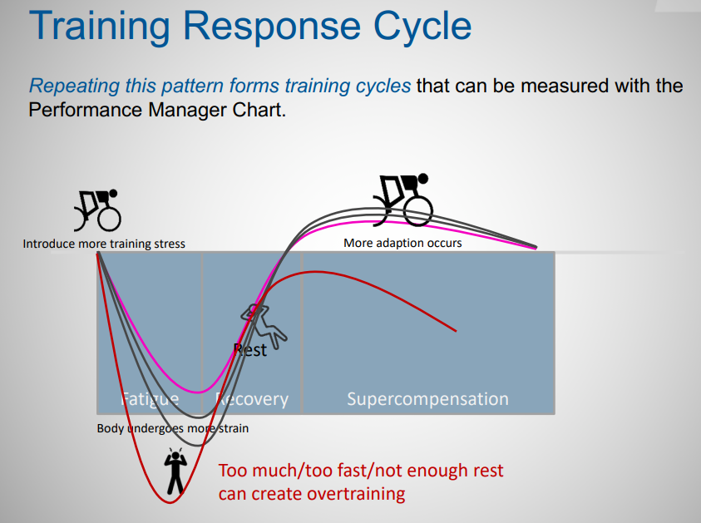
Top 5 Benefits of Quantifying
- Remove (limit) coach/athlete bias in the process
- Improve athlete diagnostics
- Individualize the needs of the athlete for specific performance
- Improve specificity in both training strategy and tactics
- Superior training and performance monitoring

As a Coach, how do I enable data?
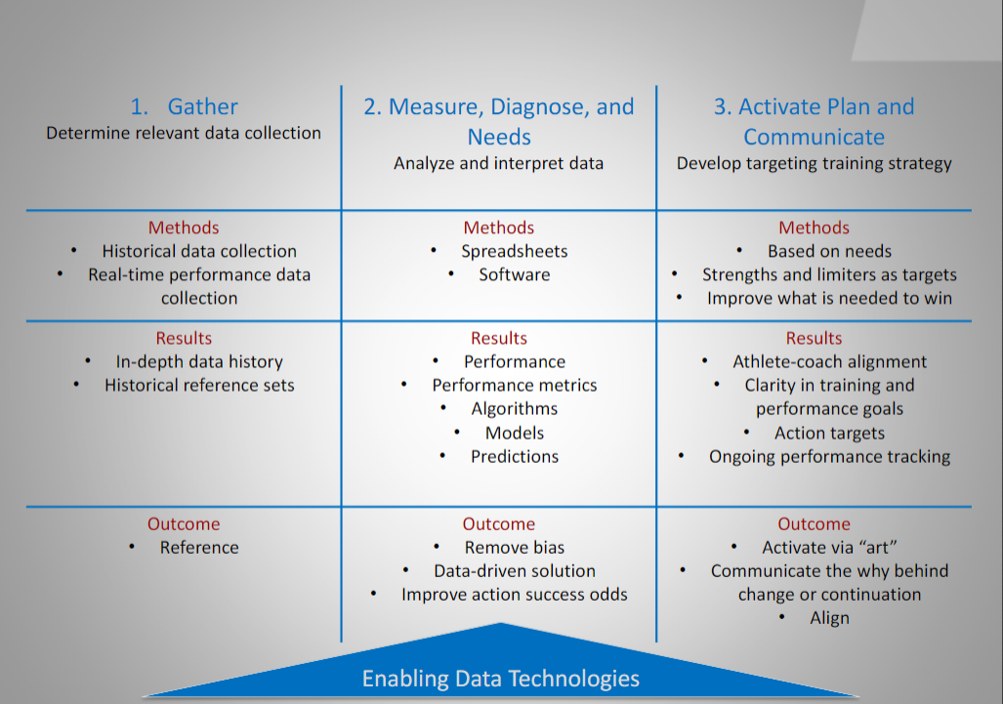
Using the exercising athletes to better understand their physiology and using their specific physiology to better understand how to specifically train them.

