The Physiology of Endurance Training
‘TrainingPeaks University’
Anatomy: the basic structure of the body and the interrelationships between various body parts.
Physiology: the study of the living processes; the understanding of how forms of life function.
Exercise Physiology: evolved from the study of anatomy and physiology and examines the function of the human body during and in response to exercise.
Sports Physiology further applies the concepts from exercise physiology, specifically to training the athlete and enhancing athlete performance within a specific sport.
Response to training is a complex phenomenon and can/will vary from athlete to athlete.
Exercise response is dependent on four things:
- Intensity of exercise
- Duration of exercise
- Frequency of exercise
- Environmental conditions
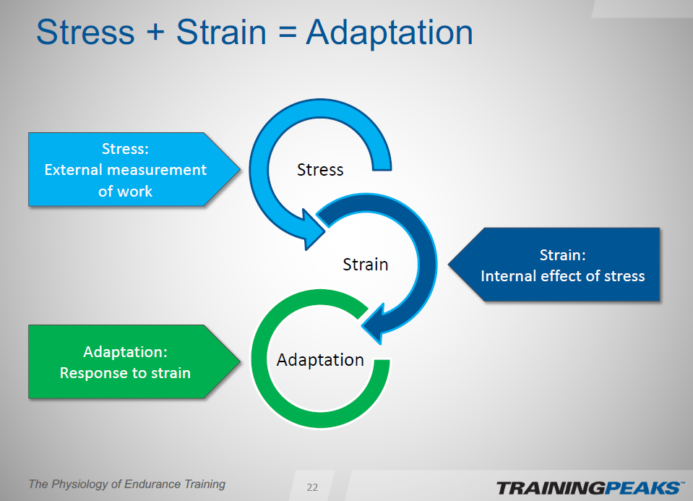

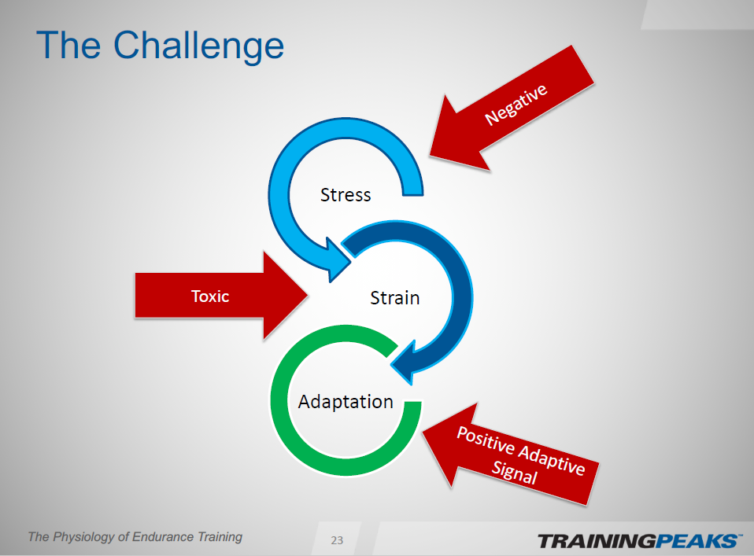
One session generally has a positive adaptation, however, training over time necessitates the need to balance the positive adaptations with the negative stresses.
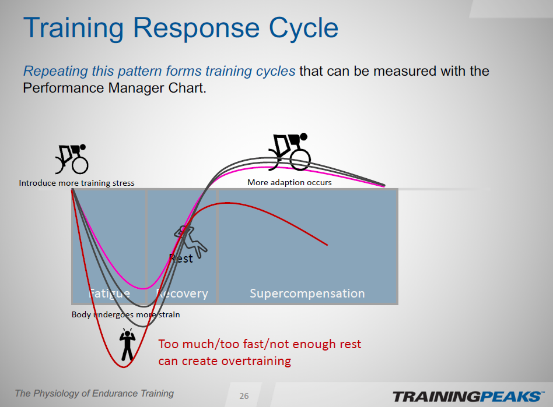
Energy Systems
There are three different energy systems. The energy system through which the body generates it depends on the Intensity and the Duration.
- ATP-PC system = very quick, explosive exercise
- Anaerobic lactic system = Moderately intense exercise lasting several minutes
- Aerobic system = Long duration exercise
ATP a compound of an adenosine molecule bonded to three phosphate groups, present in all living tissue. The breakage of one phosphate linkage (to form adenosine diphosphate or ADP) provides energy for physiological processes and biomechanical reactions such as muscular contraction. As the work of the muscle increases, more and more ATP gets consumed and must be replaced for the muscles to keep moving.
ATP Generation
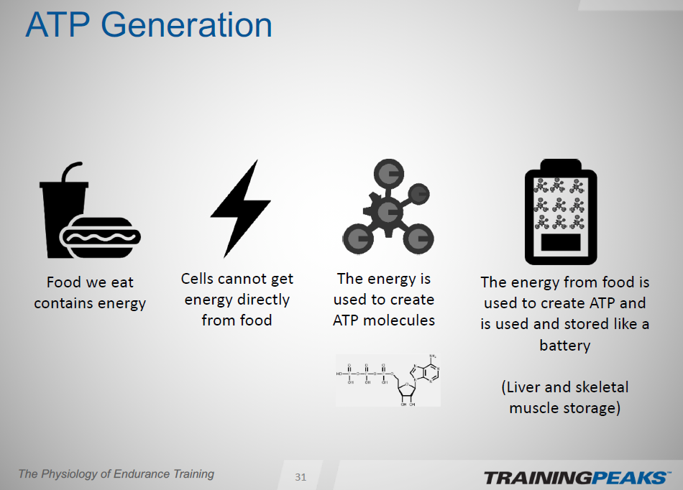

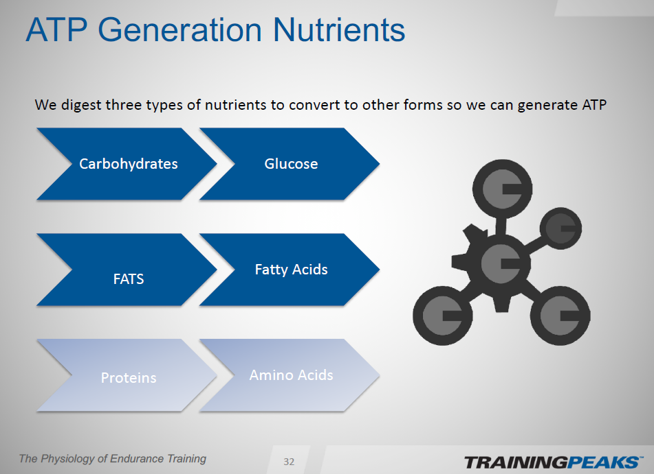

Anaerobic Training – any short-duration training that does not use oxygen and produces lactic acid build-up in the muscles. The goals of training the Anaerobic system would be to enhance or improve lactate removal and utilization. Enhance the anaerobic capacity of the muscles. Exercise, performed in short or fast bursts in which the heart cannot supply oxygen as fast as muscles use it: This system relies mainly on stored glycogen which is converted to glucose.

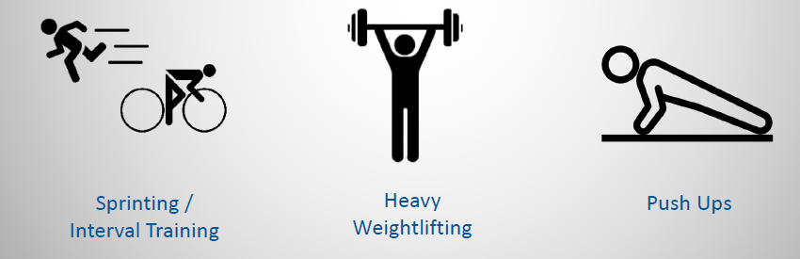

Aerobic Training – Low to high-intensity training that depends primarily on the aerobic generating process which is the ability to utilize oxygen in the production of energy to power the muscles to contract. It relies on the ability of the respiratory and cardiovascular systems. Lactic acid is controlled depending on the intensity. The goals of training the Aerobic system would be to increase submaximal endurance and Vo2 max by increasing the amount of blood pumped per beat (volume) red blood cells and increase the amount of oxygen the muscle can absorb (Vo2 Max). Exercise requires the pumping of oxygenated blood by the heart to deliver oxygen to the working muscles.
